Klaus Deutschmann
drafts – trends – developments
creating the future with passion, focus & open mind

Munich / Germany
June 2020

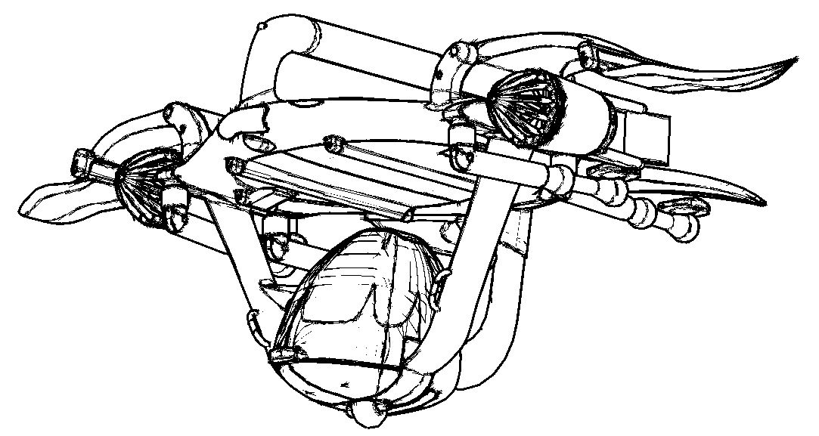
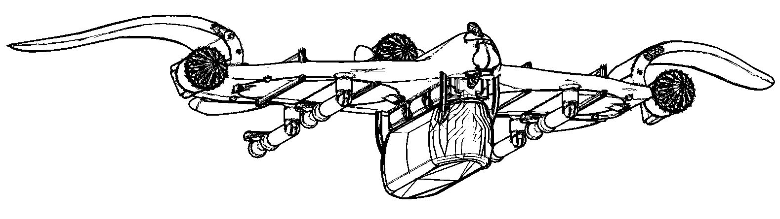
The PACKWING project

Air transport 2020 – situation & challenges

Challenges first: There are two on top – COVID-19 and its aftermath plus climate change.
We have to learn to live with the virus, which demands more decentralized structures, away from mass transport with hub & spoke, towards point-to-point systems where possible.
And we have to adapt to the consequences of climate change, which demands new means of transport in areas with thawing permafrost or frequently flooded streets – to name two out of dozens.

The situation in June 2020 is well known: The traditional aviation is in a deep crisis and it is time to think about new solutions to bring people & goods from A to B via airspace. A new air transport system based on fuel cell powered eVTOL aircraft like the PACKWINGs presented below could become one part of this solutions.

Aims & claims

PACKWINGs are designed to become the basic element of a complementary, modular air transportation system within the 21st century. In 2050 approx. 7 out of 10 billion people on this planet will live in urban centers and need new solutions to growing transportation problems mainly caused by climate change and overpopulation – and PACKWINGs have the potential to become one of these solutions.
Safety comes first, than functionality. All rotating parts are enclosed to avoid physical contact. PACKWINGs are equipped with emergency parachutes, anchor systems and overdimensioned airbags to protect health and life of passengers in cases of emergency.
Sustainability will be achieved by modular design and scalability, enabling high average utilization. Fuels for fuel cells can be made with renewable energy. PACKWINGs do not need heliports or runways, but can use them.
Flat roofs of all kinds can be upgraded to start / landing / parking / maintenance areas and equipped with refueling stations for moderate costs. A low ecological footprint, combined with higher efficiency in transportation and significant improvements in the quality of human life will create a win-win situation.
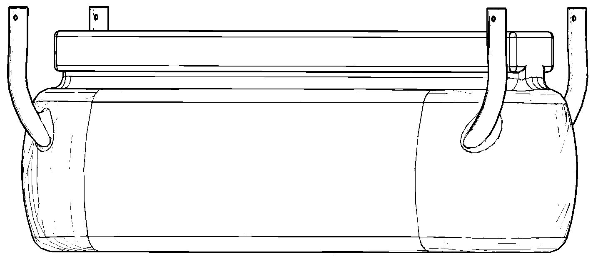
High usability in passenger and cargo transport: PACKWING passenger cabins are designed for everybody – for the elderly as well as for overweight people; for physically disabled as well as for the fit & healthy; for a single person with a lot of luggage as well as for a whole family with kids in a difficult age – and their dog of course. Cargo units are adaptable to their purpose and exchangeable easily where and when needed.
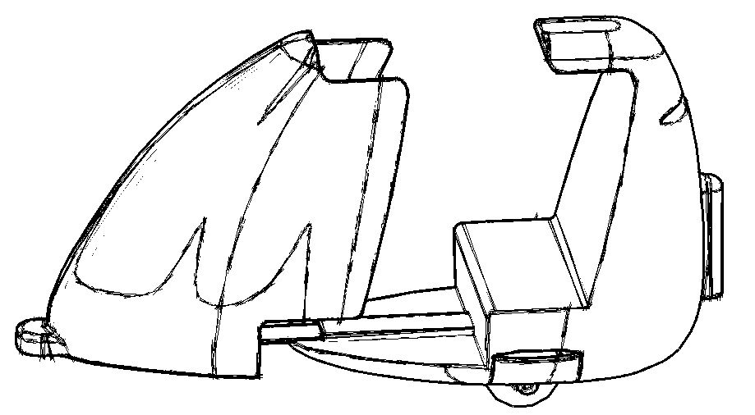

Definition

The word / term PACKWING is an abbreviation and stands for a new kind of electrically powered hybrid (half helicopter, half airplane) eVTOL-aircraft, based on a central blended wing body (= the basic module) and means:
Passive in vertical take-off & landing, just vertical rotors & e-fans are generating lift
Active in horizontal flight, the closed central wing is generating lift by its wing profile
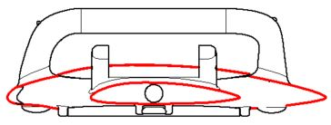
Components like lateral wings, e-fan units and cargo modules
Keeping by frames and standardized connection & stability units
W
I -body to accommodate fuel tanks & cells, sensor & control units as well as N safety features like emergency parachutes and anchor systems
G
Combined with their ability to walk on the ground PACKWINGs are also some kind of flying robot.
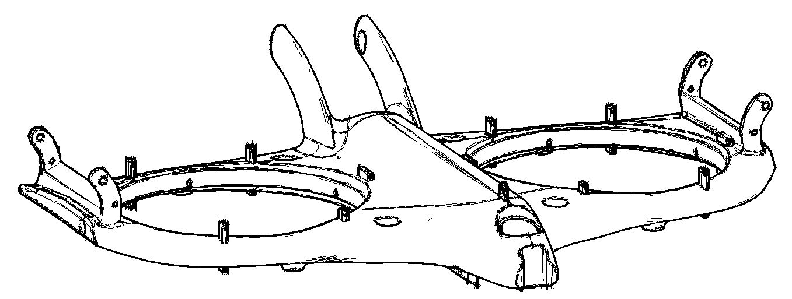
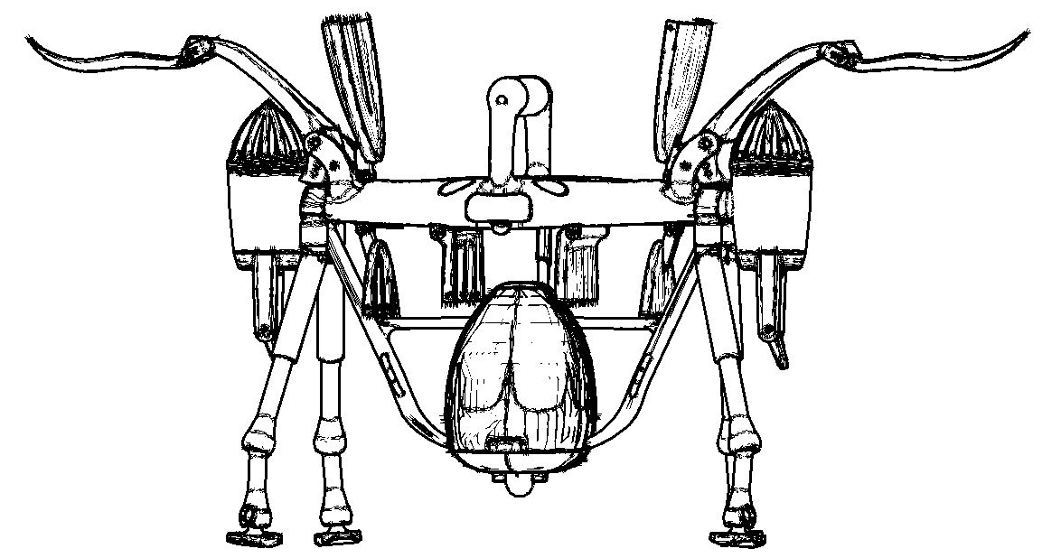
Technical features

Basic modules, bearing the vertical rotor(s), forming a central wing-body when closed
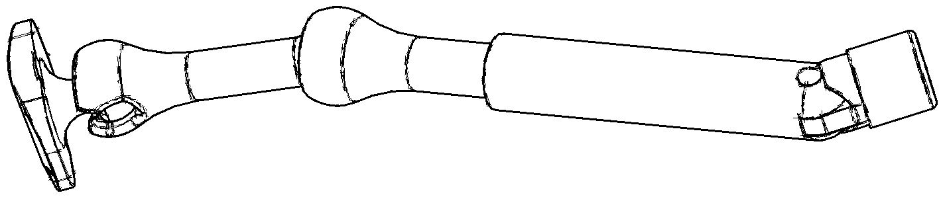
Legs as landing gear for independent movement on the ground
Vertical rotors, enclosed by shutters in horizontal flight
Rotatable e-fan units for horizontal thrust as well as adding lift in take-off & landing
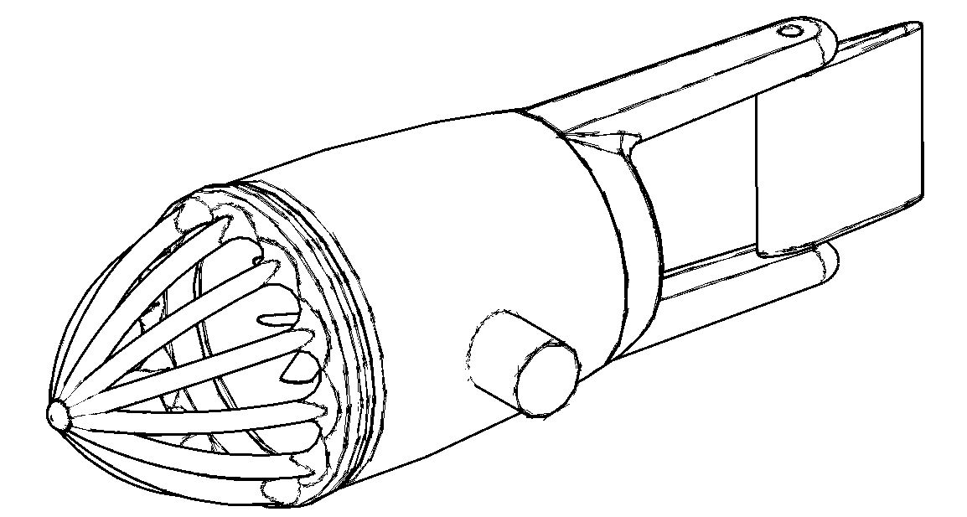
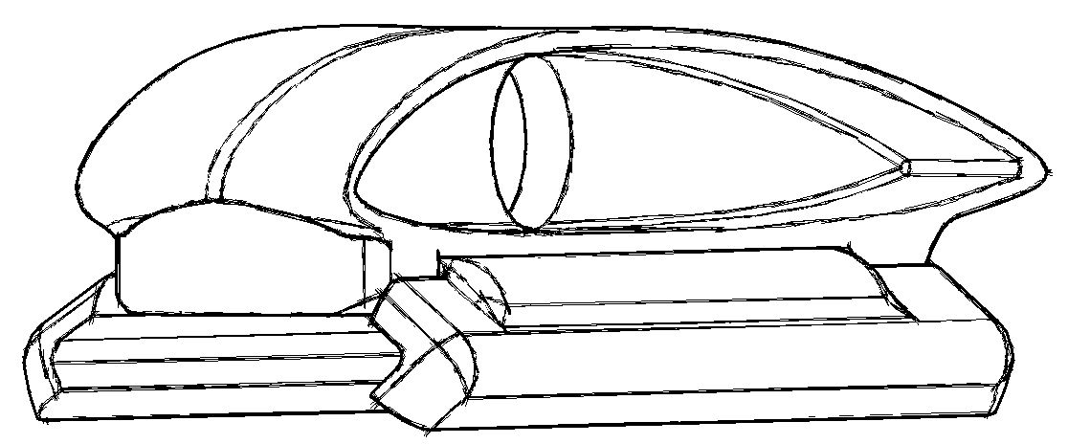
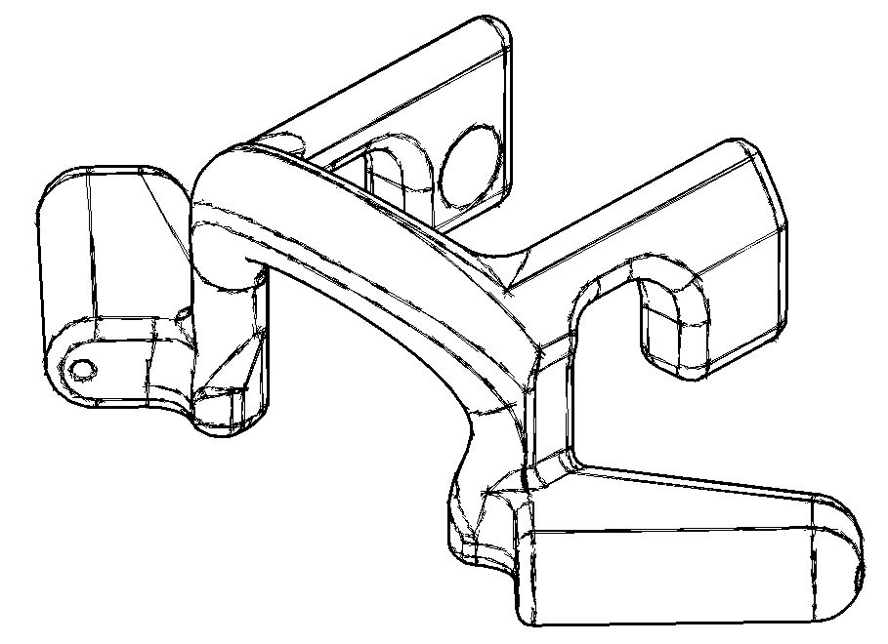
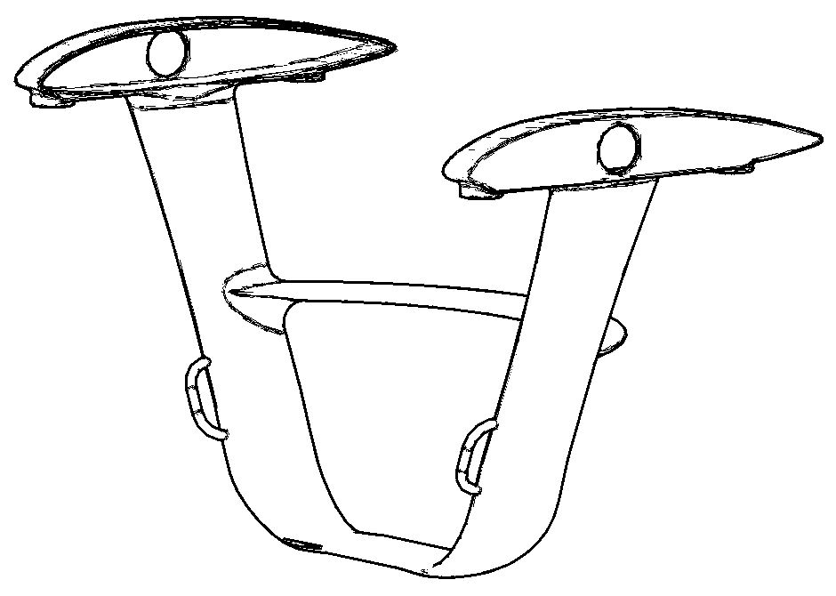
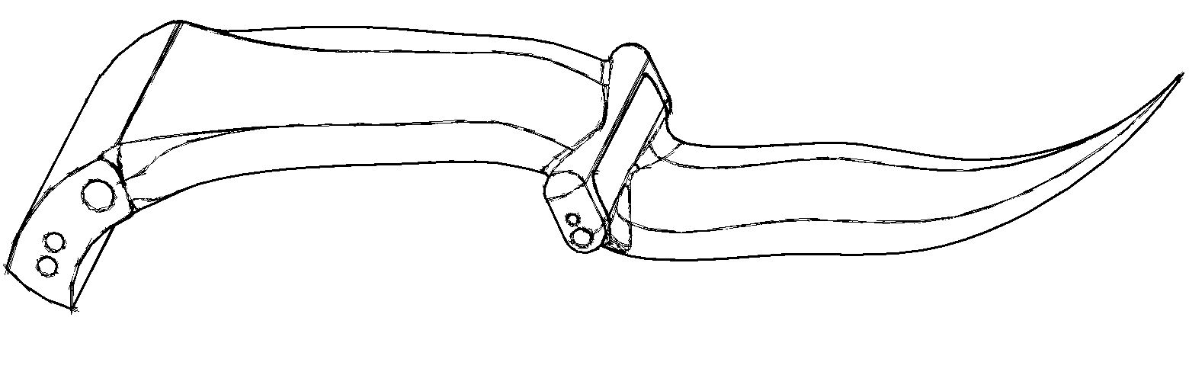

Adaptable frames to keep components / modules in place
Foldable lateral wings to reduce space needed on the ground
Basic module geometry enables combination in different constellations
Passenger /cargo modules are exchangeable according need / demand

Safety features

All rotating parts are enclosed to avoid physical contact and to reduce noise.
Emergency parachutes are attached to the basic modules, preferably four small for low opening altitudes.
Anchor systems are attached to basic modules to connect PACKWINGs to the ground where possible, especially in start- and landing areas on roofs, where turbulence and gusts occur more frequently than on even ground.
Fuel tanks are installed / assembled apart from passenger or cargo units as well as apart from critical aerodynamical structures like wings. The proposed bottle structure easily could be replaced by a multi-ball structure for a disrtributed risk of failure.
Cargo units, espec. passenger cabins can be equipped with airbags too. In a case of emergency the parachutes will slow down the speed of fall, but fail on low altitudes. Here overdimensioned airbags could avoid the worst. It is about saving lives as the most valuable to all of us. And in a case of emergency the legs can be stretched to max. length, they will be sacrificed in a crash landing for the same reason as stated above.

Application areas
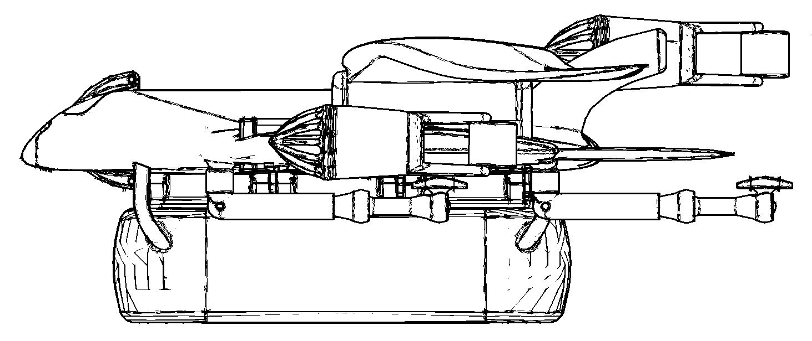

Passenger transport: e.g. urgency services in congested urban areas; cross country emergency and medical services; accident aid; connecting remote and rural areas to urban centers; leisure & sports; VIP-services; mild tourism; shuttle services for passenger transportation hubs; to meet the need for social distancing stretched passenger cabins can be segmented
Cargo transport: e.g. express goods like spare parts, medicine or medical equipment; freshness services for sea food, forest mushrooms, herbs or ready made meals; direct delivery of products from 3Dprint-clusters to customers; e-commerce
Disaster relief: e.g. in flood and earthquake areas; first aid after hurricanes, blizzards, tsunamis, wild fires and other catastrophes; firefighting
Military and police services
Sky-crane deployments by combining several basic modules to flying cranes as per need / demand / task
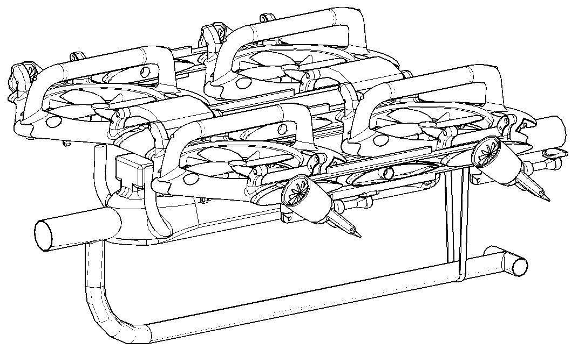
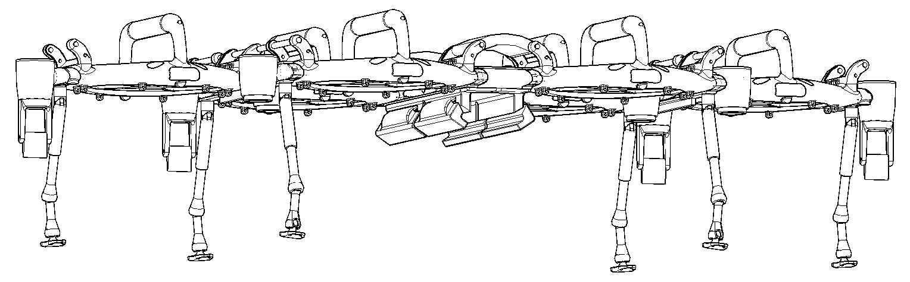

Ecological footprint

PACKWINGs do not need a new infrastructure of its own, just a few changes in the existing one. Their ability to start and land on uneven ground and hillsides, to move independently on short distances and going steps does not even require heliports. Their fuel cells can use fuels made with renewable energy.
Flat roofs on buildings including transportation hubs and shopping malls offer millions of square meters of unused urban area. Most of these roofs can be upgraded to start / landing / parking / maintenance areas and equipped with refueling stations for moderate costs. Safety for the areas around or below the start & landing areas will need special attention. All parts of the system should be designed and manufactured in a way, that they can be recycled or up-cycled once their service has ended.

Acceptance

Noise emissions of PACKWINGs will be low, fuel cell emissions as well, safety in service will be high. PACKWINGs are designed to improve our quality of life – by saving time in traffic, connecting the country side with urban centers, offering new leisure activities. Its high usability will lead to significant improvements in accident aid and emergency / medical services and will help to compensate prejudices about new technologies.
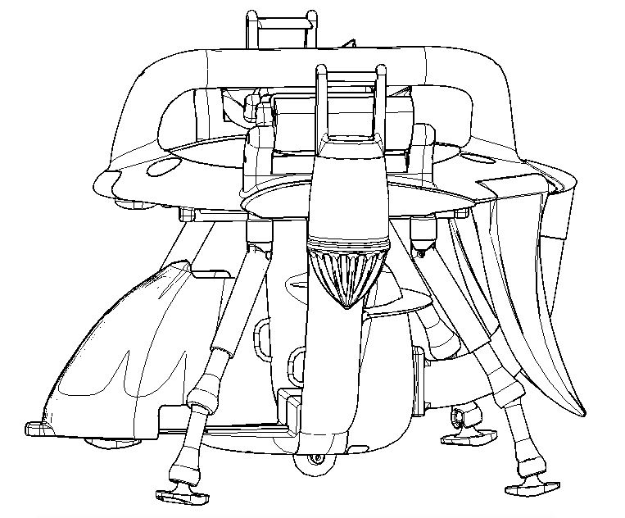
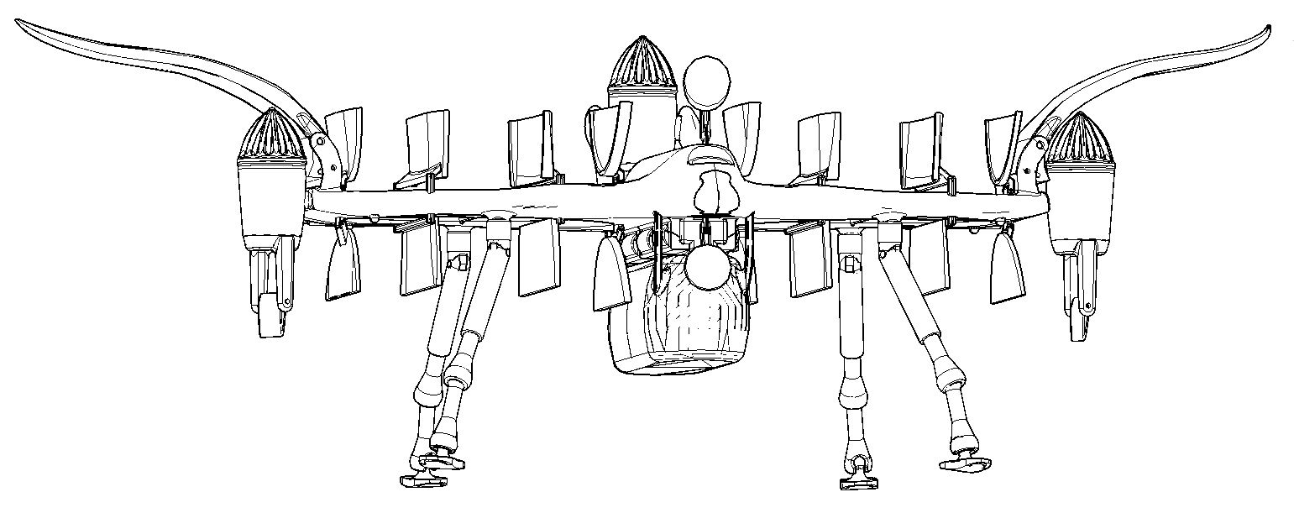

Socio-economical aspects

The modular air transportation system, based on PACKWINGs, is intended to become a complementary transportation system, fully implemented into the existing transport infrastructure within a few decades.
PACKWINGs shall not replace any existing system, but open up new opportunities to people, society, business and science. PACKWINGs will not make existing jobs obsolete, but creating new ones by pushing innovation.
After “safety first” the cost efficiency is another challenge. PACKWINGs can be used in a 24/7 system – just by changing / adapting the passenger or cargo modules according need and demand, ensuring a high average utilization - which will lead to affordable pricing for business and people.
In disaster relief the modular air transportation system will use all its advantages: Robustness, versatility and operational capability in difficult terrain including landing / starting on rocky ground and hillsides, between ruins and trees or in shallow water. Single or combined central modules will be able to bring special containers for medical aid, shelters, water processing and other duties to the areas where needed.
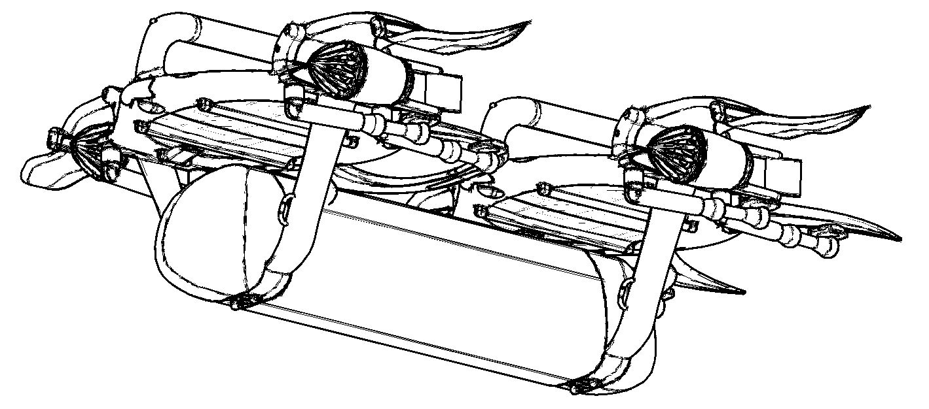
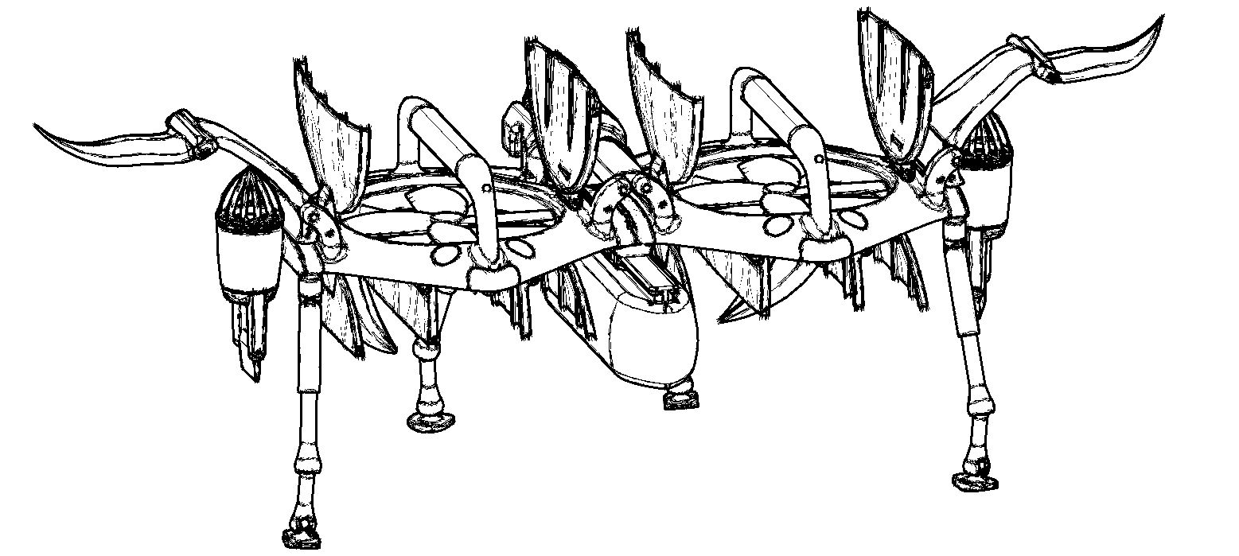

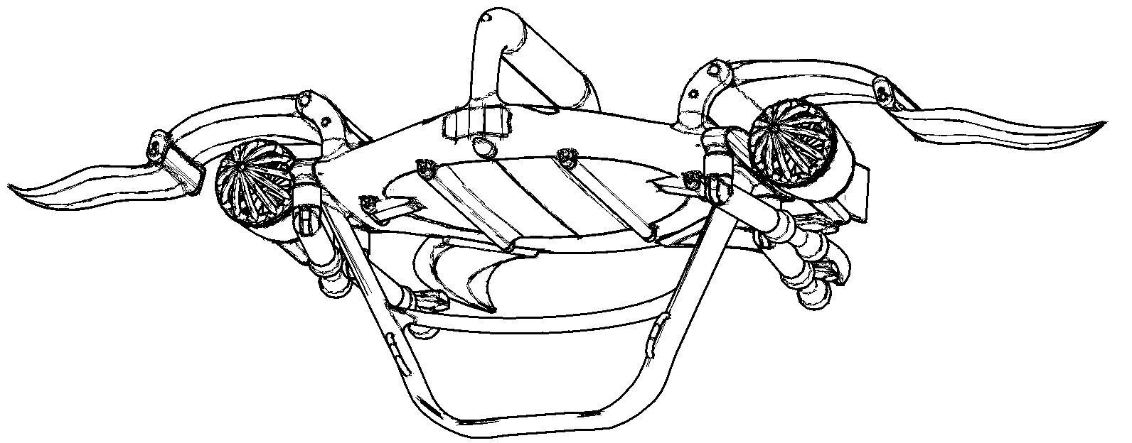
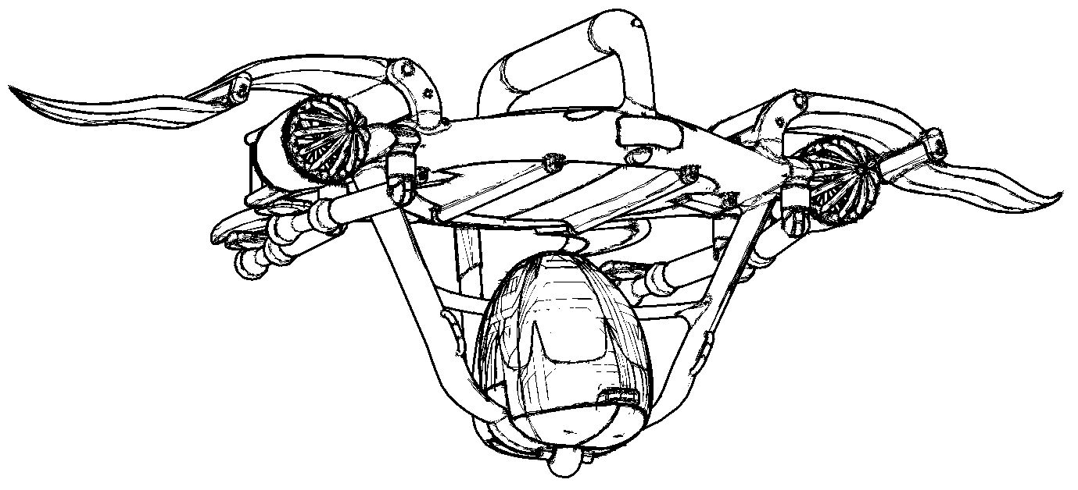
And at last, but not least: Private ownership & use –> PACKWINGs also can serve as some kind of “PGA – Personal Garage Aircraft”. With business / leisure & sports / shopping / air party or whatever cabin or module. As a leading German car manager once stated: “Our typical customer is driving to his business by business car, to sail by convertible and goes skiing by SUV.”. In the not-so-far future this customer possibly only will need one PGA - or even not this - just own the personalized cabins and / or modules. So she / he will be able to order a ready-to-fly PACKWING central module on demand at any time, which can land in her / his backyard, pick up the appropriate cabin / module and its passenger(s)
– and fly away.
Some more technical stuff

All technical data are rather estimations than exactly calculated data, mostly based on technical data of comparable systems (e.g. helicopters), examples and specialist articles, combined with some own calculations and partly based on user experience with medium sized low-speed transportation helicopters (Mi-8) and transportation airplanes (AN-2) when serving in the army of Eastern Germany in the late 1970s and early 1980s.

Speed: Operational speed of about 150 – 250 km/h (90 – 155 mph)
Range: 500 – 1000 km (310 – 620 mi)
Max. take-off weight (MTOW): from up approx. 500 kg, scalable
Average power consumption: Approx. 1 kWh per ton-kilometer (rough estimate), depending on fuel-cell efficiency, flight distance and flight altitude given by the air traffic management system (ratio of vertical to horizontal flight). Less would be more.

Challenges, obstacles and weaknesses

Societal: Techno-phobia, skepticism and pessimism have to be overcome. To generate a broad acceptance in societies will be crucial for the success of a new air transportation system based on PACKWINGs and other eVTOL aircraft.
Technical: Main challenges will be: Automated flight control; air traffic management in a congested airspace especially over urban centers; 3D-printing of large and complex composite material structures; instability of PACKWINGs when moving from vertical to horizontal flight and vice versa.
Political: Certifications, Regulations, standards, aviation law, international treaties.
Economical: Venture capital, resistance to change in the old economy.

Target & outlook

“PACKWINGs fly.” Time frame 10 – 20 years. Let´s do it.

